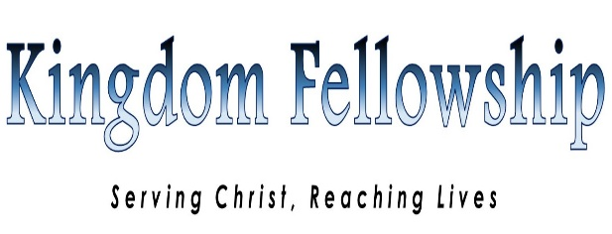

STATEMENT OF FAITH

We believe:-
1. In the verbal inspiration of the Holy Scriptures 2 Timothy 3:16
2. In the eternal existence of one true God who is Father, Son and Holy Spirit Matthew 28:19
3. In the Saviour of men, the Lord Jesus Christ, conceived of the Holy Spirit, born of the Virgin Mary, very God and very man Luke 1:31-35
4. In the creation, test and fall of man, as recorded in Genesis, his total spiritual depravity and inability to attain to divine righteousness. Gen1;2&3
5. In the Gospel of Grace of God, how that Christ died for our sins, was buried and rose again the third day for our justification. Matthew 28:1-6
6. In the salvation of sinners by grace, through faith alone in the perfect and sufficient work of Christ on our behalf upon the cross of Calvary excluding all human merit Ephesians 2:8-9
7. In water baptism of believers by immersion in the name of our Lord Jesus Christ Matthew 28: 19 Acts 2:38
8. In the baptism of the Holy Spirit as an experience subsequent to salvation with scriptural evidence, namely, speaking in tongues Acts 2:38-39
9. In the gifts of the spirit as enumerated in 1 Corinthians, being exercised and practised as manifested in the early church. 1Corinthians 12:4-11
10. In the Lord’s Supper as a memorial for believers Luke 22:17-20 1 Corinthians 11:23-26
11. In the healing of the body by divine power, or Divine Healing in many aspects as practiced by the early church Mark 8:16-17
12. In the eternal life of the believers and eternal punishment of the unbeliever.1John 5:13
13. In the Spirit-filled life, a life of separation from the world and the perfecting of holiness in the fear of God as an expression of Christian faith. Proverbs 9:10
14. In the reality and personality of Satan and demons. Revelations 12:9
15. In the reality and ministry of holy angels. Daniel 10:14
16. In the personal return of the Lord Jesus Christ for his Church I Thessalonians 4&5

